SPECIMEN INVITATION – Paper voucher
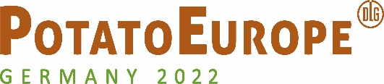

Address of your customer

05/07/2022

Invitation to PotatoEurope 2022

Dear customer,
We would like to invite you to PotatoEurope 2022, the leading meeting place of the international potato industry, which will take place from 07 to 08 September 2022 at Rittergut Bockerode near Hannover. Visit us in on Stand x.
Enclosed you will receive a voucher from us, which you can exchange online for a personal admission ticket (valid on one day between 07 - 08 September).
Important! The voucher itself is not a ticket and does not grant admission. You need to register online to obtain your personal admission ticket.
Redeeming your voucher – what to do:
1) Go online to www.potatoeurope.de/registrierung
2) Enter your voucher code and register online
3) Print out your e-ticket or save it on your smartphone
If you have any questions about the registration, you can contact the PotatoEurope Team directly, by e-mail to ticketing@dlg.org or by telephone at +49 69 24788-425.
We look forward to seeing you there!
Kind regards,

PS: All the information about redeeming your voucher is shown on the back of your voucher too.

